***SESG6039 – Composites Engineering Design and Mechanics - Individual Assignment 3  
CLPT CALCULATOR***

***Name:*** *Abhinandan Thour* ***Student ID:*** *32453515*

The aim of this assignment is to further expand the code developed in Assignment 1 based on the Classical Laminate Theory to analyse laminate stress and strain distributions, make predictions of first ply failure using different failure theories, and to predict buckling of composite and sandwich laminates.

Q1) Laminate configuration is [90, 45, -45, 0], determining the laminate strains and curvatures for the given loading conditions ,

Q2) The laminate represents a cantilever beam with with negligible width. Assuming the deflection of the beam with no forces applied is:

Q3) Figure 1 illustrate the thickness stress distribution in the laminate configuration in the (x, y) coordinate system.

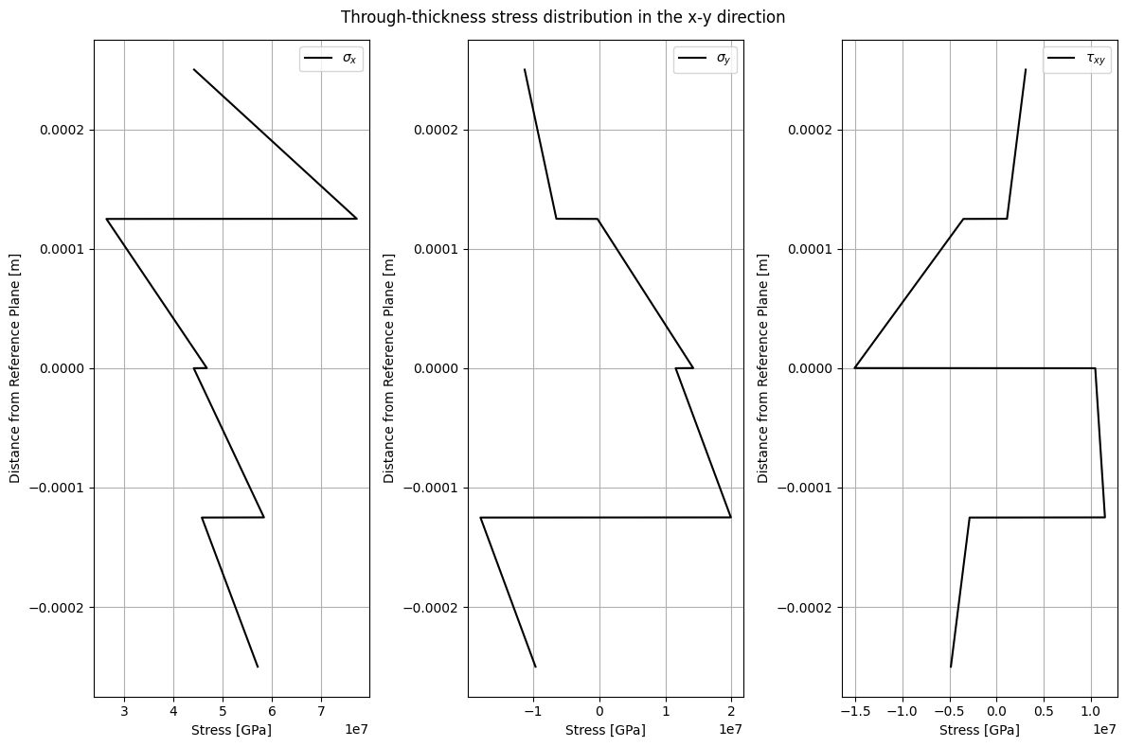

Q4)

